Spark House ChatGPT Guide
Managing workspaces teams devices usage and licensing
Edition 2 • September 22 2026


Start with the right boundaries
Use an organization-managed workspace for approved Spark House work, a named account for each volunteer, and a clearly assigned task. Add projects to organize related work. Add remote devices when a task needs their files or tools. Create another Business workspace only when a separate organization, budget, or access boundary justifies it.
This guide explains Personal and Business workspaces, why usage can feel different, how to recognize conversation limits, and how to organize a volunteer team. It covers ordinary ChatGPT, ChatGPT Work, and Codex. These surfaces can have different limits even when they appear in the same app.
The most useful finding: compare the actual plan, model, and task before comparing consumption. Business adds organizational management; the allowance comparison later in this guide explains why a Personal plan can sometimes last longer.
Status of this guide: product facts were checked against official OpenAI documentation on September 21, 2026. Tier and speed visuals were rechecked September 22, 2026. The team structure, example budgets, and review cadence are proposed Spark House practices. They do not create accounts, purchase seats, grant permissions, or adopt policy. Existing Spark House administrator decisions remain authoritative.
Reading route: volunteers should read the workspace comparison, limits, devices, and everyday workflow sections. Coordinators should also read team organization, licensing, and administration. The final pages provide a quick reference and sources.

What multiple workspaces and devices are good for
The benefit comes from matching a boundary or environment to a real need. More workspaces create more administration. More hosts create more equipment and sessions to maintain.
- Separate personal and organizational work. Keep personal experiments and purchases apart from approved Spark House records and assignments.
- Respect partner ownership. A partner organization may need its own administrators, membership, records, and budget. Agree on which organization owns a joint deliverable before connecting its sources.
- Make spending accountable. Assign a budget owner to each paid workspace and track the work it supports. Do not assume that credits or seats transfer between workspaces.
- Maintain a practice environment. Use a learning project with fictional records. A separate workspace is worthwhile only when a real account or policy boundary is required.
- Reach the right equipment. A scanning station, development machine, or document workstation may have different approved files and installed tools.
- Continue work away from a desk. Remote control can let the same authorized person steer and review a task from another device.
- Run independent work concurrently. A coordinator can review one result while another bounded task runs. Each task still consumes its applicable allowance; parallelism can increase total spending.
- Improve continuity. Approved shared outputs and documented handoffs reduce dependence on one volunteer's memory. An additional computer is useful only if access and recovery are maintained.

Choose the smallest useful addition
The team needs | Start by considering
Another outcome using the same approved sources | A new chat in the existing project
A continuing work area with its own instructions | A project with appropriate sharing
Different software, equipment, or an available workstation | An approved remote host
Another person doing authorized work | A named member and the appropriate seat
A separate organization's ownership and budget | A separately administered workspace

For example, a new heritage transcription assignment usually needs a scoped task and approved sources. It does not by itself justify another paid workspace. A partner organization managing its own people and funds may justify that separation. Record the reason and responsible owner before expanding the setup.

Understand each access layer
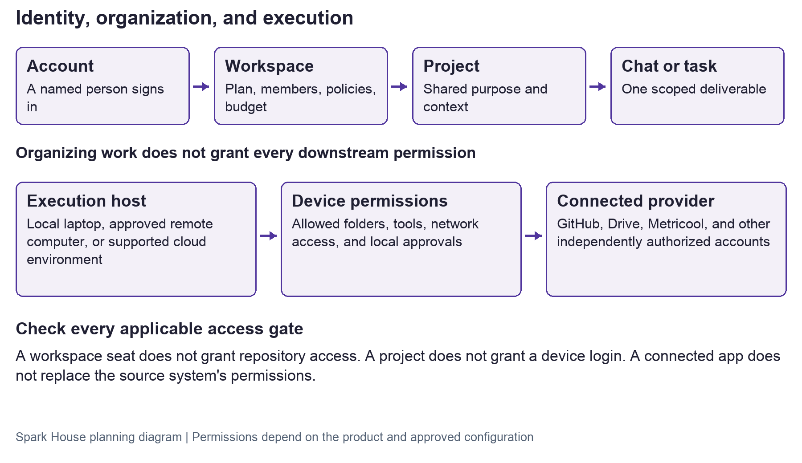
Separate layers of a ChatGPT workflow
Read the layers separately. The account identifies the person; the workspace determines membership and plan; the project organizes work; the chat holds one task; the host runs local tools; the source system controls its own records. A successful sign-in at one layer does not approve all the others. Access boundaries

Keep three permissions separate
Workspace membership permits use of the appropriate ChatGPT service. Source access permits reading or changing a specific Drive file, repository, calendar, or other service. Spark House approval authorizes the volunteer's work and any publication or insight access. The applicable local-device permissions must also allow the action. Access boundaries
Check the connected identity: a shared or agent-owned source account may have broader access than the volunteer. Restrict its permitted people, records, and actions. Local Work security
Remote limitation: supported device pairing requires the same ChatGPT account and workspace. A host is not automatically a team server that every Business member may control. Remote connections
Use Spark House's existing approval queue and account inventory. Do not build a second publication archive inside a collection of chats. Portal roles, GitHub access, and native provider permissions must be approved separately. Profile edits must never grant effective roles or permissions.

Personal and Business compared
Personal describes an individual's workspace, not one fixed paid tier. Check the actual plan name before comparing usage.
Question | Personal workspace | Business workspace
Intended management | The individual manages their use | Organization-managed membership and billing
Plan choices | Free, Go, Plus, and Pro options | Business seat and credit options shown in the actual workspace
Useful Spark House role | Public learning and personal work | Approved organizational tasks and team administration
Identity controls | Individual account controls | Essential administration, SAML single sign-on, and multi-factor authentication
Model training | Review the current Personal Data Controls before using work material | Business data is not used for training by default
Work and Codex allowance | Depends on the actual individual plan | Standard Business does not automatically exceed Personal Pro
Sharing | Share only deliberately and with the right audience | Membership does not make every conversation an approved team record
Leaving the team | A person's private account is not an organizational handoff system | Administrators manage removal; preserve approved outputs before departure

Plan and identity-control facts: OpenAI pricing. Business privacy: local Work security. Membership, local permissions, and connected-source access remain independent: access boundaries.

Choose a workspace for the work
Keep Spark House's restricted material in approved organizational systems. Do not move it to a Personal plan merely because that plan has more allowance. A volunteer can practice with fictional or already public material without receiving private operational access.
Use team projects within the primary workspace where their sharing settings fit the need. If another organization controls the records, first agree on ownership, permission, billing, and the handoff location. Do not assume a subscription covers membership in every Business workspace or that separate workspace balances are pooled.

Switching is different from merging
Selecting another workspace should be treated as choosing a different work context. A migration or merge is a separate administrative decision. Before accepting a migration dialog, verify what moves, whether it can be reversed, who controls the result, and what export and departure options remain. Preserve only permitted copies in approved storage. This guide does not establish the migration or export behavior of your particular account.
Business is not Enterprise. Do not budget on the assumption that standard Business includes custom roles, SCIM directory provisioning, or every Enterprise audit control. Check plan eligibility and the actual settings. User lifecycle

Why the Business allowance can disappear faster
Several causes can operate together. These are explanations to test, not a finding that OpenAI charged this workspace incorrectly.
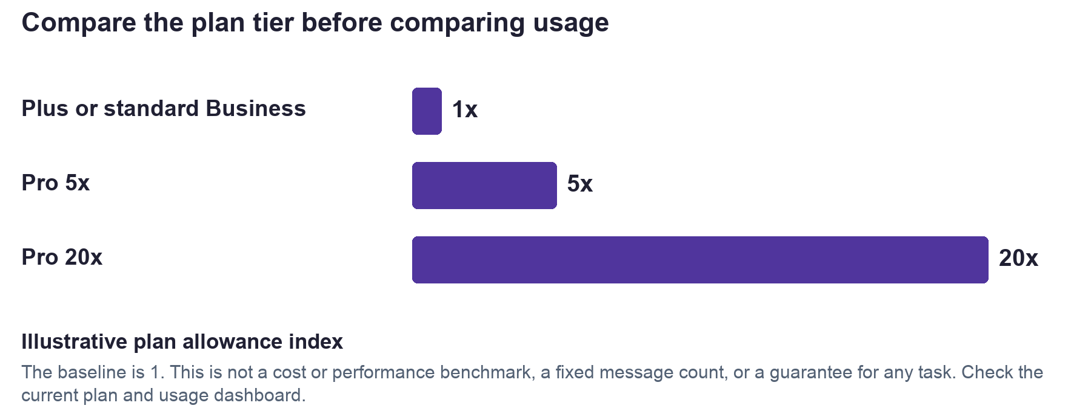
Relative allowance index for standard Business Plus and Pro
The index illustrates the published plan relationship for Work/Codex, not exact message counts, model performance, or dollar charges. OpenAI pricing
- The starting allowance differs. Confirm whether the Personal account is Pro and the Business seat is standard or another supported tier.
- One request starts many steps. Research, reading files, using tools, checking a document, and revising it can all happen behind one visible prompt. Work consumption depends on model, task, environment, and settings. Work usage and cost
- Speed can cost more. Where available, Astra and GPT-5.6 Fast mode use 2.5 times the Standard credit rate. That can spend an allowance faster even when a task finishes sooner. Speed
- Other activity shares the meter. ChatGPT Work and Codex share usage. On eligible agreements, other features and people can draw from workspace credits. Inspect the exact balance being displayed. Speed, Work usage and cost
- More information means more processing. Long histories, large source sets, verbose tool results, and repeated searches may expand what the model processes. Cached input can be metered differently; visible prompt length alone is not a bill. OpenAI pricing
- Concurrent tasks overlap. Three running tasks can use the same applicable budget at once. Adding another device does not isolate their charges or replenish the account.

Compare equivalent work
Use the same non-sensitive sample, output requirement, model, reasoning level, speed setting, and local or cloud mode. Record the workspace and seat type, usage before and after, report timestamp, and all concurrent or scheduled activity. Compare several completed samples; a single short prompt is a poor benchmark. Stop unnecessary work before taking measurements.
Account-specific limit: this guide did not inspect Spark House's Business invoice, credit ledger, per-person caps, or warning text. Confirm those details before buying credits or changing a subscription.

Identify the limit before choosing a fix
A context window is the information the model can consider at once. It is different from the saved transcript and from how much usage remains. Compaction summarizes older context so work can continue; it does not provide unlimited verbatim recall. OpenAI glossary
What you see | What it may mean | Useful next step
Usage limit with a reset time | A time-window allowance is exhausted | Check the active plan and reset time; wait or request an approved capacity decision
Credit balance exhausted | Eligible paid usage has consumed its pool | Administrator checks balance, shared activity, and permitted overage
Monthly user cap reached | A supported administrator usage control has stopped that user | Ask the budget owner to review the assigned limit
Conversation too long or context full | The chat or current input has reached a context or product boundary | Save a handoff and start a focused continuation; include only needed sources
File too large or upload limit | A file, upload count, or storage boundary | Check that feature's current rule; split or reduce permitted source material
Host offline or tool unavailable | Device availability, configuration, or permissions | Check the selected host and access; buying credits may not address it

Credit controls depend on plan and activity. They do not govern Platform API billing. Usage limits and spend controls

Why a long thread can feel constrained
The model may need room for instructions, relevant earlier messages, retrieved text, images, tool results, reasoning, and a response. A saved chat can be longer than the working context available to any one turn. Different models and surfaces handle this differently. An API model's published token maximum is not a promise about the ChatGPT interface.
The reviewed documentation does not establish a universal rule that Business threads are smaller than Personal threads. Record the exact warning, app version, model, workspace, time, and approximate attachments. Remove private content before asking a coordinator or support to investigate.

Continue without losing the work
Ask for a handoff containing the objective, approved decisions, source locations and editions, completed work, current files or branch, checks already run, unresolved questions, and next action. Verify it. Start a new chat in the same appropriate project and provide that handoff plus necessary files. Keep related follow-up in the current chat while it remains useful. Projects, long-running work
A new chat helps context organization. It does not reset billing or usage allowances. Save final work in the approved record system; do not rely on chat memory as the only copy.

Organize the volunteer team
Recommended starting structure: one Spark House Business workspace with projects for distinct work areas. These are proposed names, not a statement that the projects or permissions already exist.
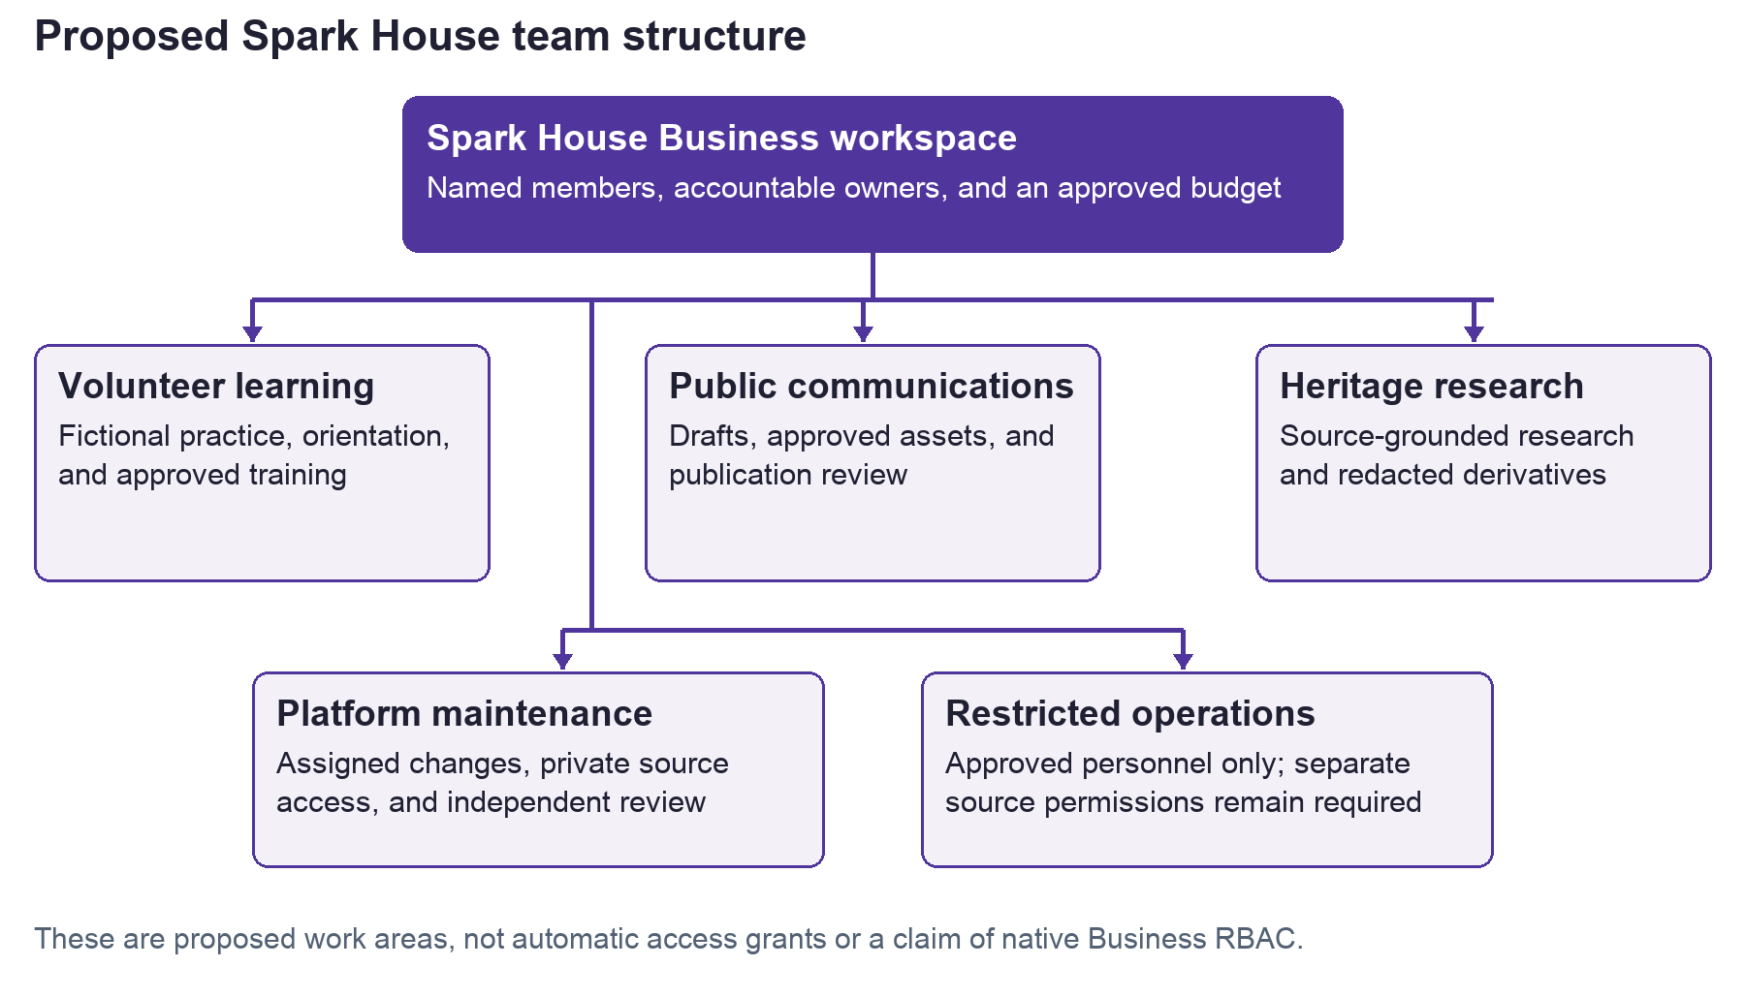
Proposed Spark House team project structure
Responsibility | Who should hold it | Practical boundary
Workspace ownership and budget | Small designated owner group with a documented backup | Approves spending, membership, and supported workspace settings
Routine administration | Named administrator where needed | Processes approved access changes and reviews the member list
Task coordination | Assigned coordinator | Defines scope, reviewer, source permissions, and completion criteria
Volunteer contribution | Named member with active volunteer status | Works only within approved training, role, and task scope
Review and publication | Designated reviewer and authorized publisher | Checks sources, privacy, and rights; publication remains a separate decision

These responsibilities are an operating model, not a set of promised native Business roles. The coordinator and reviewer titles do not imply ChatGPT administrator privileges.
A shared project should contain only material approved for everyone who can access it. Names such as “Restricted operations” are labels, not security controls. Test sharing with a representative member before adding sensitive sources. Local project folders and worktrees organize work; the sandbox and operating system enforce local access. Projects

License people and budget for completed work
Spark House practice requires named accounts. Treat a seat as access for a person, rather than a shared shift login or a license attached to a scanning computer. A person using several approved devices is not several volunteers. Automation credentials require a separately approved design and the supported authentication method. User lifecycle, authentication

Published price checkpoint
On September 21, 2026, standard Business is listed at $20 per user per month billed annually for at least two users, or $25 monthly. Pro starts at $100 monthly with 5x or 20x Plus usage options. The pricing guide maps Business at $100 to Pro 5x estimates. Verify available seat options, checkout, taxes, and contract terms before committing. OpenAI pricing

Illustrative eight volunteer budget
Item | Example calculation | Planning amount
Eight standard seats on annual billing | 8 × $20 × 12 | $1,920 per year; $160 monthly equivalent
Eight standard seats on monthly billing | 8 × $25 | $200 per month; $2,400 for 12 unchanged months
Difference before usage and taxes | $2,400 minus $1,920 | $480 across 12 months
Variable AI usage | Approved allowance for purchased credits or overage | Set from measured pilot results
Other costs | API usage, provider licenses, host operation and recovery | Budget separately when applicable

This is arithmetic using the posted standard-seat prices, not a quote or Spark House's current bill. An annual monthly equivalent is not a promise of monthly payment or flexible cancellation. Confirm seat-reduction and renewal terms before choosing annual billing.

Purchase only what the role needs
Start with a short pilot and review completed outputs, quality, rework, and time saved alongside spending. Give frequent users an appropriate supported allowance only when the evidence warrants it. Do not buy a seat for every community supporter who never uses ChatGPT, and do not share one paid identity among several active users.
Do not assume a new Business workspace can purchase Codex-only seats. Current guidance restricts those seats to qualifying existing Business workspaces and other eligible plans. User lifecycle
API-key work is billed through the OpenAI Platform account. A ChatGPT subscription does not pay that separate API bill. Authentication

Connect and operate remote devices
Start with one approved host and one accountable operator. Remote uses the host's files, tools, browser sessions, and permissions. The host must remain online, awake, and running the desktop app. Availability and controls vary by rollout. Remote connections

Before connecting
- Assign the host a clear name such as SPARK-SCAN-01 or SPARK-DEV-01, an equipment custodian, and an approved purpose.
- Use the approved operating-system account and protected storage. Keep private records off personal devices, consistent with Spark House's records-steward rules.
- Confirm the ChatGPT identity, workspace, approved project, and permitted source systems. Enable multi-factor authentication through the appropriate account or identity provider.
- Update the app and operating system. Review the files, browser accounts, plugins, and tools the host can expose. Connect only what the assigned task needs.
- Define who may operate the host, who reviews output, and how to stop a task. A team schedule must not become a shared human login.

Pair and verify
On the host, open Settings, Connections, and Control this Mac or PC. Start setup and pair the controller using the displayed flow. Confirm the same account and workspace; workspace policy may need to allow Remote Control. Pair each controller with each approved host it needs. Remote connections
Test a harmless task using a fictional file. Confirm the displayed host, output location, permissions, and approval behavior. Review the result on the host before relying on the connection for a real assignment.

During and after a session
Keep a Windows host dedicated to the task when Computer Use needs the foreground session. If a host becomes unavailable, first check power, network, app state, and sign-in. A local execution environment still uses online AI services; Remote does not make ChatGPT a disconnected LAN service. Remote connections
For parallel code changes, assign distinct worktrees and a reviewer. For shared documents or calendars, name one writer at a time. Device handoff is not a substitute for saving and verifying the deliverable. Long-running work
At handoff, record the task state, save approved outputs, review remaining activity, and release the equipment to its next authorized operator. For a lost device or departing operator, have the administrator review pairings, account sessions, source-system grants, and credentials together.

Use an efficient everyday workflow
Choose ordinary Chat for an explanation or short draft. Choose Work for a larger deliverable that needs sources or tools. Choose Codex for code and development tools. Define the result, sources, audience, and review criteria before running a large task. Prompting

Before starting
- Confirm the active account, workspace, project, and host.
- Name one deliverable, its intended audience, and what counts as finished.
- Attach the minimum relevant approved sources and dates. Use fictional data for practice.
- Choose a model and reasoning setting proportionate to the difficulty. Use Standard speed unless the deadline justifies a faster paid mode.
- Set the boundary for external action. Preparing a draft, granting access, sending a message, and publishing are different decisions.

Three Spark House examples
Public communications. “Use these approved event facts to draft a 150-word announcement for volunteers. Preserve the dates and organization names. Flag missing information, cite the source, and save a draft for the coordinator. Do not post or send it.”
Heritage research. “Use Spark House's established research framework and identify the relevant hypothesis or general question. Compare the two approved source excerpts. State exact editions and dates. Separate supporting, qualifying, and challenging evidence. Preserve uncertainty and rights notes. Prepare a pending reading assessment for review.”
Platform maintenance. “Investigate this reproducible public-page issue in the canonical Spark House repository. Preserve permissions and concurrent work. Make a focused change with relevant checks, documentation, changelog, and a reviewable pull request. Report any checks you could not run.”
These prompts are examples. They do not authorize a volunteer to access restricted source or private records. Repository history can contain sensitive material even when the current page is public.

While the task runs
Steer an existing task when correcting the same objective. Start another chat for a distinct outcome. Avoid repeating a large source upload in every message. Stop unnecessary retries or optional polishing. Authorize parallel agents only where their independent results justify the additional usage and can be reviewed without competing writes. Prompting, long-running work

At completion
Check names, dates, citations, calculations, rights, and privacy. Save the approved artifact in the existing record system. Keep proposed interpretations distinct from adopted policy. Research metadata is not evidence that a full text was read. New publication snapshots and changed reading assessments retain pending review. Keep raw GEDCOM trees, private notes, and dissertation file references out of public feeds.

Administer access and spending
The cadence below is a recommended operating practice. Use the existing private account inventory and approval records, with references to source systems instead of copied private content.

Join a volunteer
- Verify active status, written role, training, task owner, and reviewer.
- Record the intended workspace, supported seat, budget owner, and review date.
- Invite the named account using supported workspace controls. Confirm the correct identity and authentication protections.
- Grant only the required project, host, and source access through their respective administrators.
- Complete one fictional practice task and verify both permitted access and a relevant denied path.

Change or end an assignment
Review access when duties change. At departure, preserve approved team deliverables, reassign required workflows, remove workspace membership, revoke applicable tokens, and remove source-system and device access separately. Transferring a project or GPT does not automatically transfer the former member's private conversations and files. User lifecycle

Review usage weekly during a pilot
Record seat fees separately from credits consumed and actual additional charges. Where supported, use individual limits and a workspace overage control. Alerts notify people; they do not stop spending. A balance reaching zero can pause eligible features when overage is unavailable or disabled. Confirm reporting time and the billing period. Work usage and cost
If standard Business does not expose a desired granular control, use the supported workspace controls and a documented manual process. Do not describe a suggested budget as an enforced technical cap. Usage limits

Keep a small management register
Record | Minimum useful fields
Person and seat | Named identity, workspace, seat type, active status, approver, renewal or review date
Role and task | Written role, assignment, coordinator, reviewer, approved source references
Device | Host name, custodian, permitted operators, purpose, pairing review date
Spending | Budget owner, billing period, included allowance, purchased credits, actual charges, report timestamp
Departure or change | Outputs handed over, memberships removed, grants revoked, exceptions and owner

Never place passwords, API keys, account hashes, recovery keys, private submissions, or billing credentials in this register. Reference the approved vault or system without copying secrets.

Quick reference for volunteers and coordinators

The terms that matter
Term | Meaning in this guide
Account | A person's sign-in identity
Workspace | A membership, administration, and plan context
Seat | A person's supported product access within the workspace
Project | Related chats, instructions, and approved source context
Thread or chat | The conversation for a task
Host | The computer or environment running local tools
Connector or plugin | A way to reach tools or sources, subject to permissions
Token | A unit of information processed by a model
Credit | A unit used to pay for eligible usage under the applicable plan
Context window | Information the model can consider at once
Compaction | A summary of older context used to continue a long task
Rate limit | A usage or throughput restriction over a time window

Product terminology: OpenAI glossary, access boundaries.

Common questions
Will five computers give me five times the allowance? Plan access follows the authenticated account or workspace and its applicable limits. Do not budget on a device multiplier. Parallel jobs may consume that allowance sooner.
Does a Business workspace give every volunteer my connected computer? No. Device pairing, workspace feature access, local permissions, and source-system rights are separate controls.
Should each team get a paid workspace? Usually begin with projects and appropriate sharing. Consider another workspace when ownership, administration, funding, or data boundaries require one. Check the membership and billing consequences first.
Will a new thread solve a credit warning? It may organize context, but it does not replenish usage. Identify the meter and warning before taking action.
Can a plugin run our production integration? A ChatGPT connection is not a deployable provider credential. Spark House's server integrations need their own approved credentials and permissions.
Does this guide grant a role or publish a policy? No. Administrator decisions and the existing review processes govern access, publication, and adoption.
Before every substantial task: confirm identity, workspace, host, sources, expected output, reviewer, and usage setting. Before sharing: verify the artifact, audience, and authorization.

Visual reference: plans and capacity
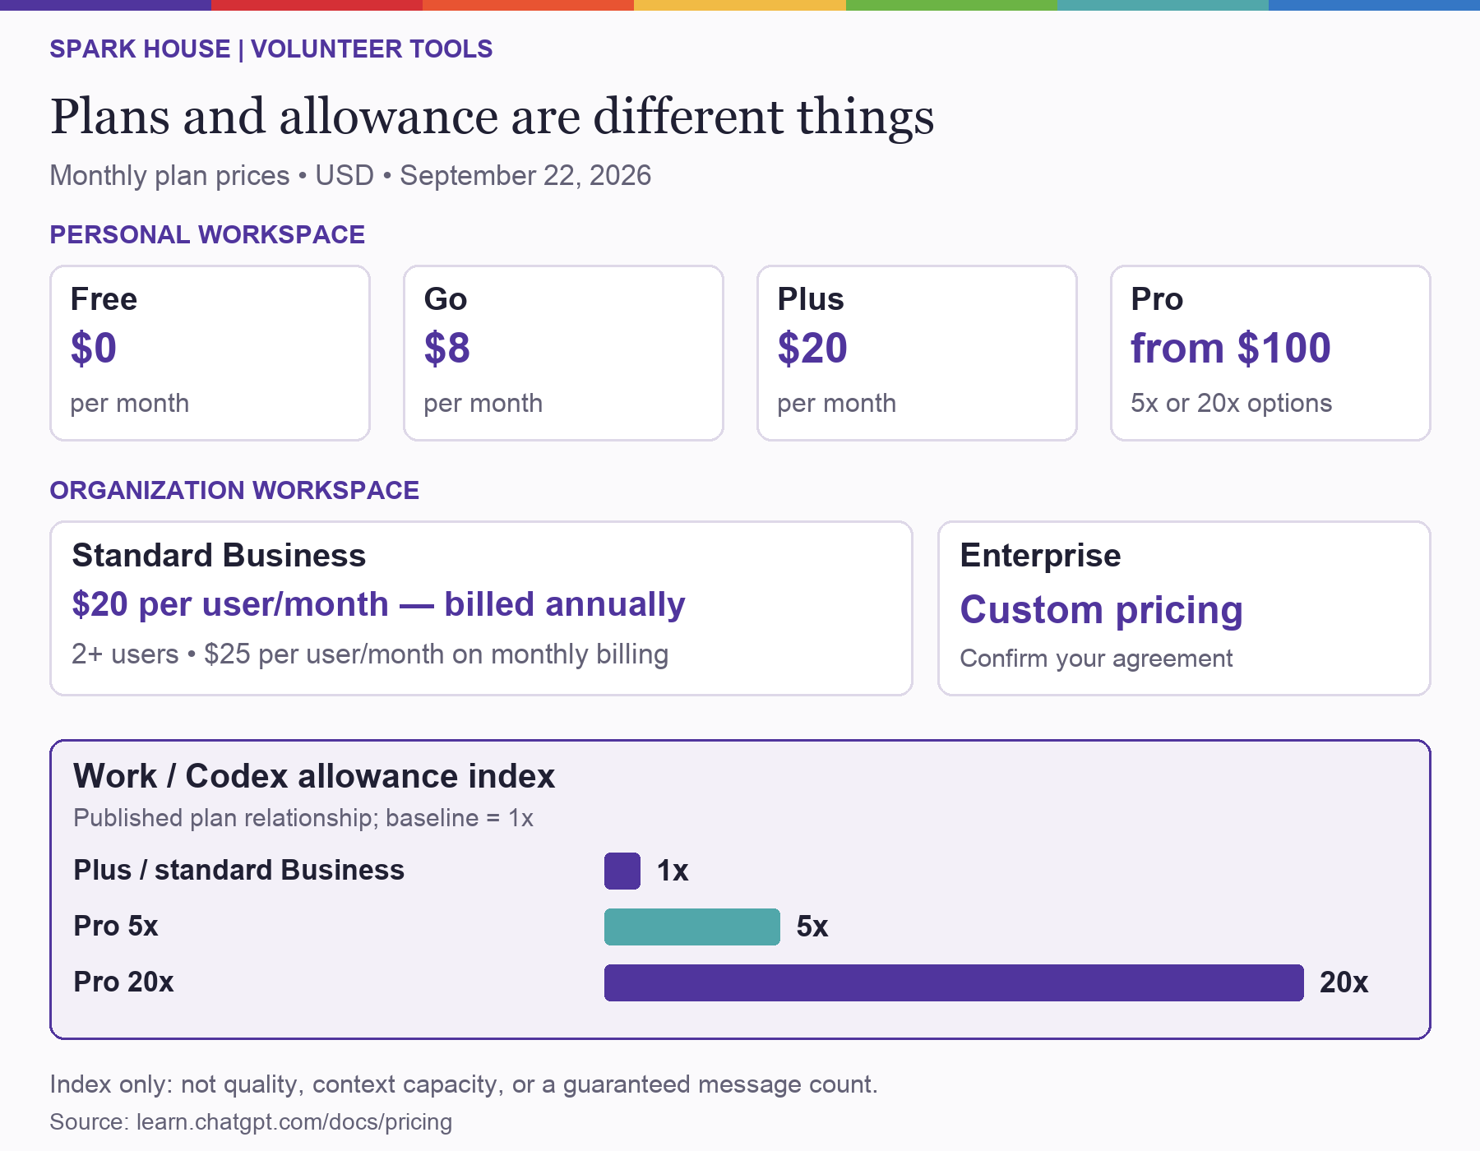
Personal plans and organizational plans are separate choices. Free $0, Go $8, Plus $20, and Pro from $100 monthly; Business $20 per user monthly with annual billing or $25 monthly, minimum two users; Enterprise custom. Work and Codex allowance index: Plus and standard Business 1, Pro 5x 5, Pro 20x 20.
Compare the purpose, then the allowance. Personal plans serve an individual; Business and Enterprise provide organizational administration. A larger number in the Work/Codex index does not mean better answers, a larger context window, or more device permissions. Current pricing
Read the exceptions. Free and Go have no comparable numerical index here. The Business $100 option uses Pro 5x estimates; verify available seat terms. Enterprise allowances depend on the agreement. Prices are published USD examples; check regional checkout, taxes, and current terms before purchasing.

Visual reference: limits and credit use
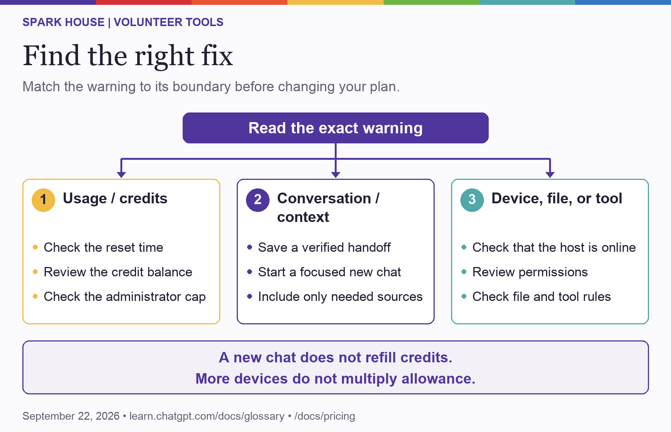
Read the exact warning, then choose usage or credits, conversation or context, or device file and tool troubleshooting. A new chat does not refill credits, and more devices do not multiply allowance.

One budget, two speed settings
Illustrative GPT-5.6 example: assume an identical task costs 20 credits at Standard speed. At the documented 2.5x Fast credit rate, the example costs 50 credits. A hypothetical 100-credit budget covers five Standard examples or two Fast examples. This is not a fixed message price, your balance, an invoice estimate, or a promised speed increase. Real costs vary with tokens, tools, context, and caching; API-key pricing is separate. Speed settings
Follow the right meter. The seat subscription, allowance or eligible workspace credit pool, and actual invoice are different numbers. Consuming committed credits does not automatically create an equivalent extra invoice charge. Work usage and cost
Try the interactive speed illustration in the Spark House visual guide.

Sources and maintenance
Official OpenAI pages were inspected on September 21, 2026; tier, allowance, and speed visuals were rechecked September 22, 2026. Product names, prices, eligible seats, and settings can change. Consult the current page and actual workspace before procurement or an administrative change. Links throughout the guide identify the supporting topic; examples and suggested team practices are Spark House recommendations.
- Pricing — current Work/Codex plan relationships, published seat prices, and usage information.
- ChatGPT Work usage and cost — shared credits, usage versus invoices, and supported spending controls.
- ChatGPT usage limits and spend controls — scope of workspace controls and separate API billing.
- Speed — Fast mode and shared Work/Codex usage.
- Glossary — context, tokens, and compaction.
- Projects and chats — project context, local folders, and task organization.
- Long-running work — task continuity, independent chats, and competing writes.
- Remote connections — host pairing, account/workspace matching, and device requirements.
- Roles and workspace permissions — independent access boundaries.
- User lifecycle management — joining, changing roles, departure, and plan-specific controls.
- Authentication — ChatGPT sign-in and separately billed API-key work.
- Prompting — selecting the right work surface and scoping a useful result.
- Local Work security — Business data protection and connected-account boundaries.

Spark House source rules
This guide also follows AGENTS.md, CONTRIBUTING.md, docs/START-HERE.md, docs/operations/REPOSITORY-WORKFLOW.md, docs/operations/SECRETS-AND-BACKUPS.md, docs/metricool-integration.md, docs/research-foundations.md, and integrations/research/README.md in the canonical private SparkHouseMN/sparkhouseplatform repository. The original logo is public/SPARK.jpg; colors and typefaces follow the existing site styling. Private repository access is not required merely to read this volunteer guide.

Maintain this edition
Assign a document steward and an administrator reviewer before organizational adoption. Review prices and limit guidance before a purchase, after a material product change, and at the next scheduled license review. Update the editable source and both distributed editions together. Record the verification date and unresolved limitations. Retire obsolete copies through the existing document process.
The guide includes no live volunteer inventory, credential values, private billing records, or adopted access grants. It explains a management approach; it is not an audit of the Business workspace or a software release.

