01 BRAND GUIDE

Brand Guide

Susi McCune Memorial Library
Founded May 17, 2025

Digital Print Community materials
Use this guide to present the memorial library clearly and consistently across websites, documents, signs and shared community materials. It gives collaborators the artwork, naming rules and production checks needed to keep the library recognizable while respecting the identity of every participating organization.
Edition 1.0 | October 26, 2026

Prepared for Spark House community materials
02 BRAND GUIDE

Identity and naming
The library name is the foundation of this identity. Use it in full and keep the memorial purpose clear without adding unsupported claims about Susi or the organizations involved.

Use the complete name
Susi McCune Memorial Library is the public name. Keep the spelling and capitalization exactly as shown. Write the name in deep purple whenever color is supported. In plain text, keep the complete name; color cannot be conveyed through text alone.
Use “Founded May 17, 2025” when the founding date is useful. The date is a separate supporting line, not a permanent part of the logo. Do not shorten the public name to an acronym, add a legal status, or substitute a business name.

Keep the memorial artwork distinct from evidence
The open book, heart, flowing thread and violet flower form the memorial mark. Preserve these recognizable elements together in the primary artwork. The mark is prepared memorial artwork. It is not a historical logo, a photograph, or artwork attributed to Susi.
Original portraits, plaques, letters and book covers retain their own appearance and attribution. Use the library identity around those sources rather than repainting, relabeling or altering them.

Explain the role in the actual project
Use the library identity for reading, heritage and community participation materials within the authorized project. Keep the library distinct from Spark House and Friends of the Isanti Library. A logo placement does not combine their funds, records, governance or authority.
On Spark House materials, feature the memorial library first and prominently.
On partner-led materials, preserve the partner’s primary identity and acknowledge the library only for its actual role. Keep the event, author or public service easy to find. Do not add a sponsorship claim solely because a logo appears in the template.
03 BRAND GUIDE

The logo system
Choose the artwork for the space available. Preserve the full name in readable text rather than forcing the complete mark into a tiny square.

Primary and horizontal versions. Keep each version’s proportions and lettering unchanged.
Application | Preferred treatment
Covers and larger signs | Use the complete primary artwork with clear space.
Website header or small sponsor row | Pair the mark with readable purple live text. Do not rely on tiny lettering inside the image.
Small icon or avatar | Use a supplied compact icon only. Keep the full name nearby or in its accessible label.
Dark or photographic background | Place the purple artwork on a clean light plate with ample clear space.
One color production | Use an explicit supplied monochrome file. Ask for a production proof before releasing it.

Keep the complete primary artwork intact. Do not reset its lettering, remove the flower, change the heart or redraw the flowing line.
Use the outlined SVG masters for scalable production. PNG exports support Word, presentations and applications that do not accept SVG.
04 BRAND GUIDE

Clear space and scale
Protect the logo’s outline and lettering. Crowded placement and undersized lettering are the most common causes of poor reproduction.

Leave breathing room
For the complete primary mark, reserve clear space on every side equal to at least one tenth of the artwork’s displayed width. Keep text, rules, crop lines, other logos and page edges outside this area. The supplied transparent canvas is not a substitute for checking the visible artwork.
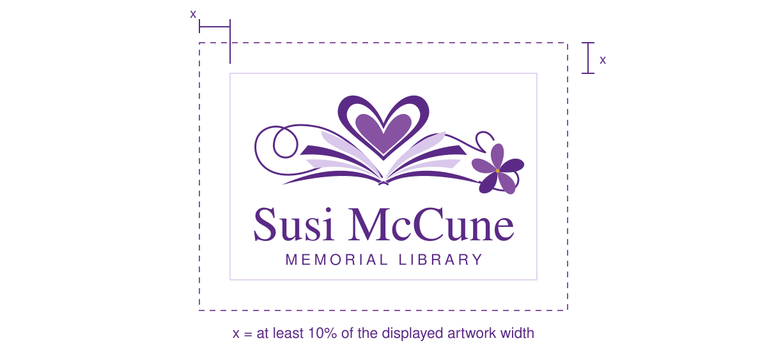
Clear-space diagram. The outer frame shows the protected area, not a border to print around the logo.
Use | Working minimum | Check before release
Primary artwork on screen | 280 CSS pixels wide | The MEMORIAL LIBRARY line remains readable.
Horizontal artwork on screen | 440 CSS pixels wide | Keep the descriptor readable; switch to compact text when space is narrower.
Primary artwork in print | 2.5 inches wide | Inspect an actual-size print, especially on absorbent stock.
Compact digital identity | 120 pixel symbol width | Keep the full name in nearby live text; give links a generous interaction target.

These are design working minima, not guarantees for every printer or display. If a reproduction fails at the intended size, increase it or use the compact identity with readable text. Do not stretch the logo to fill a fixed box.
05 BRAND GUIDE

Color and contrast
Purple is the library’s defining color. Use a light background and reserve the lighter shades for supporting surfaces and decoration.
Color | HEX | RGB | CMYK approx
Deep purple | #5B2A86 | 91, 42, 134 | 32/69/0/47
Violet | #8752A1 | 135, 82, 161 | 16/49/0/37
Lavender | #D9C8EB | 217, 200, 235 | 8/15/0/8
Flower center | #D6A52C | 214, 165, 44 | 0/23/79/16
White | #FFFFFF | 255, 255, 255 | 0/0/0/0

RGB and HEX values are the digital reference. The warm flower center is a small decorative accent. CMYK figures are unprofiled approximations, not spot colors. Ask the printer to proof the purple on the intended stock.

Use tested text pairs
Pair | Ratio | Guide use
Deep purple on white | 9.90:1 | Body text
White on deep purple | 9.90:1 | Body text
Deep purple on lavender | 6.33:1 | Body text
Violet on white | 5.60:1 | Body text
Lavender on white | 1.57:1 | Decoration only

For ordinary interface and document text, use at least 4.5:1 contrast. Large text has a 3:1 minimum under WCAG guidance. The logo exception does not extend to body copy or event details. Keep important information readable even when the mark itself is decorative.
Do not use lavender type on white for essential information. Identify states and categories with words or symbols as well as color.
06 BRAND GUIDE

Typography
Use a quiet serif for the library’s name and main display headings, supported by a clear sans serif for instructions and details.
Susi McCune Memorial Library
Nimbus Roman | Display and editorial headings
Reading Heritage Community
Nimbus Sans | Body text, navigation and practical information
Role | Print starting size | Web starting size
Main page heading | 26 to 32 pt | 32 to 48 CSS px, responsive
Section heading | 15 to 18 pt | 22 to 28 CSS px
Body and instructions | 11 to 12 pt | 16 to 18 CSS px
Supporting details | 9.5 to 10.5 pt | 14 to 16 CSS px

Use comfortable line spacing and left-aligned paragraphs for reading. Keep long passages out of capitals. Do not condense type to meet a page count or insert extra letter spacing into the library’s proper name.
The supplied artwork’s lettering is outlined as part of the logo and should not be reset. Editable surrounding text uses the type system above. If these fonts are unavailable, choose a readable serif and sans serif, then reflow and inspect the result.
Font files are not included in this kit. Check the applicable license before installing, redistributing or embedding a font in a new environment. Keep required notices with any permitted distribution.
07 BRAND GUIDE

Web and digital use
A readable name, a clear purpose and a useful link matter more than displaying every part of the artwork at every size.

Build a responsive identity
Use the primary artwork for broad feature areas. In a narrow header, show the compact artwork with the complete name as purple live text. Let the name wrap naturally instead of shrinking it until the image lettering becomes unreadable.
On Spark House pages, keep the memorial library in the top feature area. Preserve the site’s own navigation, identity, sign-in controls and audience. A library acknowledgement must not suggest access to another organization’s private records.

Label images and links for their purpose
When the logo alone links to the library’s information, give the link a text alternative that names its destination. If the same link already contains the complete name as visible text, use an empty image alternative to avoid repeating it.
Placement | Suggested text
Standalone identity image | Susi McCune Memorial Library
Logo alone linking to heritage intake | Susi McCune Memorial Library heritage contributions
Logo next to the same readable linked name | Empty image alternative; visible link text supplies the name.
Founding date as supporting text | Founded May 17, 2025

Protect reading and participation
Keep event details and instructions as real text. Ensure visible keyboard focus, useful link labels and reflow on small screens. Language choice must preserve the proper name and must not send private page content or form values to a translation provider.
Use approved local assets rather than a third-party hotlink. A public brand package contains public artwork only. It must not include private family, health, legal, financial or volunteer records.
08 BRAND GUIDE

Print and physical materials
Choose the artwork size from the viewing distance and production process. A web image can be excellent on a page and still be too small for a large sign.

Know the source resolution
The primary SVG is the scalable master. The companion PNG is 4,000 by 2,700 pixels. At 300 pixels per inch, its canvas supports a width of 13.33 inches before resampling. Enlarging a PNG does not add detail; use the SVG master when the process accepts it.
For a large exterior sign, vehicle wrap, embroidery or cut vinyl, give the supplier the vector master and confirm the production limits. Some processes need simpler linework or a dedicated stitch or cutting file. Review that derivative and a production proof before ordering.
Material | Prepare | Proof
Office letter or handout | Keep editable text and export a matching PDF. | Inspect at actual size; confirm all links and phone digits.
Full bleed commercial print | Use the printer’s trim, bleed and safe-area specification. | Check crop marks, background coverage and protected logo area.
Posters and outdoor signs | Increase name and event type for the actual viewing distance. | Read a scaled proof at a comparable distance.
Embroidery or one color items | Use a supplied production variant and the supplier’s stitch or line limits. | Approve the physical sample before the full order.

Keep the name readable
Use generous margins. Give dates, location and the next action their own space. Keep a small Spark House production imprint within the safe area when appropriate, and keep the official marks of participating partners unchanged.
The reusable documents include the approved Spark House page watermark. It is applied once in the editable source, then carried into the PDF. Do not add a second watermark or replace it with an unrelated medallion.
09 BRAND GUIDE

Partner identity and contact routes
Show the library’s contribution clearly while preserving the name, authority and public contact of each organization involved.
Context | Hierarchy
Spark House led material | Susi McCune Memorial Library first, followed by the Spark House identity and the project details.
Partner led material | The partner remains primary. Acknowledge the memorial library where it participates, with a discreet Spark imprint for creative support.
Author feature | Give the author and authentic book cover the main feature area. Keep participating sponsor marks in a smaller acknowledgement row.
Historical photograph or plaque | Preserve the original evidence. Add the current identity outside the source image.

Use the verified public routes
Direct heritage contributions and requests through the Spark House contribution route and identify Susi McCune Memorial Library as the destination. Do not invent a separate library email address or publish a private coordinator’s contact details.
Purpose | Public route
Heritage contributions and requests | https://www.sparkworks.org/contribute
Spark House coordination email | volunteers@sparkworks.org
Spark House public phone | 763-444-3669

Label the email and phone as Spark House contacts. Their inclusion does not promise a library response time, open hours or interpreter availability. Confirm arrangements before advertising them.
Use Friends of the Isanti Library in new surrounding copy. The approved source logo retains its original embedded wording. Preserve the official colors, proportions and orientation of Lions, Knights and other partner marks. A logo asset alone does not establish participation in a new event.
10 BRAND GUIDE

Reusable materials
Start with the correct template, keep the identity area intact, and replace every content placeholder before release.
Template | Use | Complete before sharing
Editable letterhead | Letters, handoffs and short project notes. | Date, recipient, subject, message, sender and the correct public contact.
Announcement HTML | A small editable notice or announcement. | Event or service title, actual details and one clear next action.
Sign layout SVG | A sign layout for later production. | Trim size, readable headline, verified details and printer proof.
Social layout SVG | A social graphic layout with editable text. | Crop-safe wording, date and route; include a plain-text caption.

Write in a direct community voice
Lead with what a person can do and give the details needed to take part. Use concrete names, dates, places and contact routes. State who is organizing the activity and what each partner is contributing. Keep a warm invitation grounded in the actual arrangements.
Do not invent quotations, sentiments, achievements, book titles, availability or endorsements. Preserve a contributor’s own words and distinguish them from new surrounding copy. Use ordinary punctuation and omit authorship-production credits from public prose.

Use the artwork faithfully
Do | Avoid
Use purple identity on a clean light field. | Recoloring the name to match another organization.
Keep width and height proportional. | Stretching, squeezing, skewing, shadows or glow.
Keep the complete name readable. | Using a tiny full logo as the only identification.
Keep originals and create a new edition. | Overwriting historical evidence or archived event artwork.

11 BRAND GUIDE

Release and maintenance
A useful brand system stays easy to find, clear to apply and honest about what has been checked.

Review the final material
- Check the complete library name, purple color and founding date.
- Confirm that the mark is sharp at its final size, proportional and surrounded by clear space.
- Verify the project details, public links, contact labels and actual partner participation.
- Inspect every page or crop for clipping, small type, poor contrast and hidden private information.
- Keep the editable source with its matching PDF or release image and record the edition used.

Maintain one current asset set
Use the supplied asset manifest and named files as the current release set. Preserve previous editions separately. When artwork or a public route changes, update the master first, then the website components and reusable templates that depend on it. Historical originals remain unchanged.
The guide sets design rules. It does not certify accessibility, archival conformance, trademark clearance or printer readiness. Check the actual output and preserve the project’s existing publication and access permissions.

Sources and scope
The identity, purple palette, memorial artwork and preservation rules follow Augustine’s standing directions of October 9 and October 26, 2026. The founding date is May 17, 2025. The October 26, 2026 refinement is a new edition of the memorial artwork, not an image attributed to Susi.
Contrast guidance: W3C WCAG 2.2 Understanding Success Criterion 1.4.3. Ratios in this guide were calculated from the stated sRGB values. https://www.w3.org/WAI/WCAG22/Understanding/contrast-minimum.html
Image and link alternatives: W3C Web Accessibility Initiative Functional Images tutorial. https://www.w3.org/WAI/tutorials/images/functional/
Next step Choose a template and prepare one finished material for its intended audience.

